The issue exporting the Developers Notes is this:

I’m trying to export this structure:



And everything works except the content of the notes.

I manage to import the file with no problems using this structure:

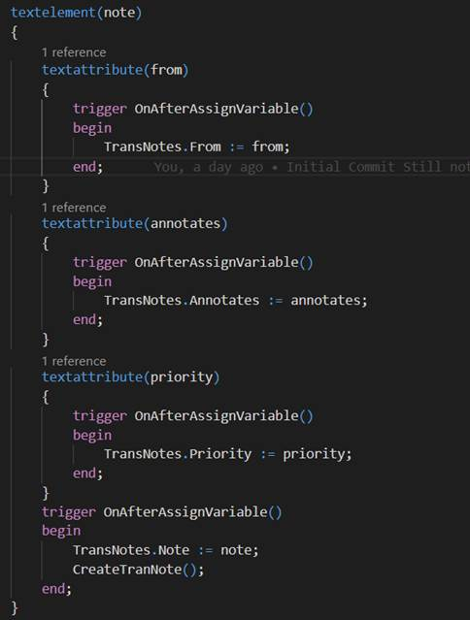

But I cannot do the same on the output.

I can get the notes like this:

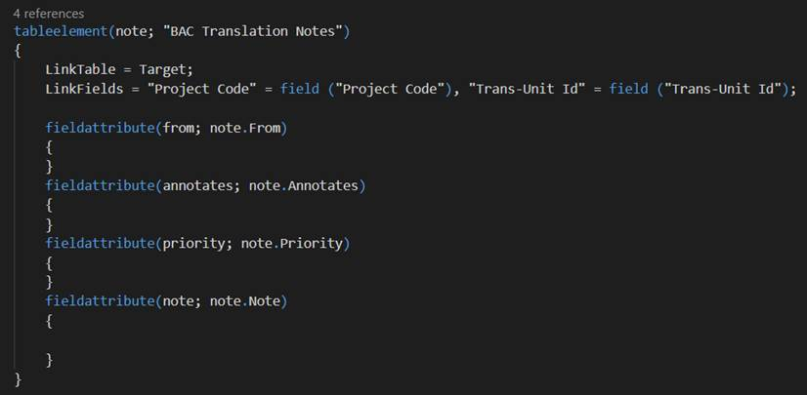

But I cannot get the content of note in any way possible.

Any help?